6) AgDegBW

The model calculates a) an ambient mobile-bed equilibrium, and b)the response of a river reach to either 1) changed sediment input rate at the upstream end of the reach starting from t = 0 or 2) changed downstream water surface elevation at the downstream end of the reach starting from t = 0, where t is the temporal coordinate. The code is very similar to AgDegNorm described in Chapter 5 of this user’s guide. The main difference between the two codes is in the procedure to compute the water depth. In AgDegNorm the flow is assumed normal (i.e. steady and uniform), while in AgDegBW the flow is assumed steady and it is computed solving the backwater equation. The case of Froude-subcritical flow, for which Fr < 1 (refer to Chapter 5 “Review of 1D open channel hydraulics” of the e-book), is considered herein. This implies that integration of the backwater equation must proceed upstream from x = L, with x streamwise coordinate and L length of the modeled reach. Both a Chezy and a Manning-Strickler formulation can be used to compute the flow.
For a detailed description of the theory and of the model, the user should refer to Chapter 20 “Aggradation and Degradation of Rivers: Backwater Formulation” of the e-book, and to the word file RTe-bookAgDegBWFormul.doc, downloadable at
http://vtchl.uiuc.edu/people/parkerg/word_files.htm.

The upstream boundary conditions are specified in terms of a sediment feed rate in metric tons per year, G_{tf}, a characteristic flood discharge, Q_{w}, and a flow intermittency, I_{f}. The downstream boundary condition is given in terms of a known water surface elevation, ξ_{d}, with
(6.i)
where η denotes the bed elevation and H the water depth. As opposed to the normal flow calculation, downstream bed elevation η(L,t) is no longer specified, and is free to vary during the run, i.e. the Exner equation is implemented at node M+1.

The initial bed profile is the same as the one used for the calculations using the normal flow approximation, eq. (5.vii) i.e. at t = 0 the initial bed elevation at the downstream end of the reach is set equal to zero.

Input parameters of the model are
- the characteristic flood discharge, Q_{w}, and the flood intermittency, I_{f};
- the channel width, B_{c};
- the characteristic diameter of the sediment, D;
- the bed porosity, λ_{p};
- the roughness height, k_{c};
- the ambient bed slope, S;
- the imposed annual sediment transport rate, G_{tf};
- the imposed water surface elevation at the downstream end of the reach, ξ_{d};
- the length of the fluvial reach, L;

The user also has to specify the following parameters to perform the calculations and to control the output:
- the number of sub-reaches, M;
- the temporal step length, Δt;
- the upwinding coefficient a_{u};
- the number of time steps to printout, N_{toprint};
- the numbers of printout in addition to the initial equilibrium state, N_{print};
- the coefficient α_{r} in eq. (5.i);
- the parameters to define the load relation, , and n_{t}, defined in eq. (5.ii);
- the constant to convert the total boundary shear stress to that due to skin friction, ϕ_{s};
- the submerged specific gravity of the sediment, R.

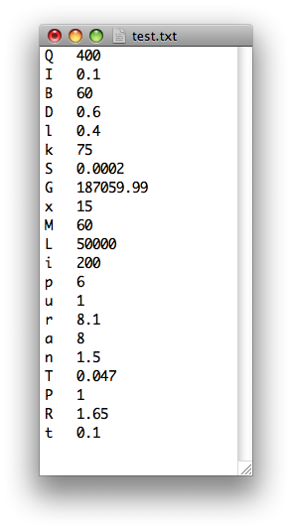
The text file with the definition of the input parameters and an example of input file are shown in the two windows below.
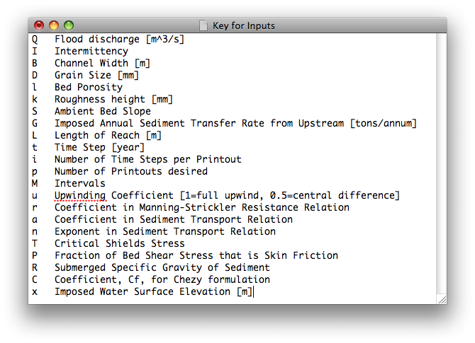

The output parameters of the model printed in the text file Output.txt are the bed elevation, η, the channel slope, S, the water depth, H, and the water surface elevation, ξ, at the different times t_{plot,j} defined in eq. (5.viii). An example of output file is reported in the window below. The values of bed elevation, water surface and water elevation at t = 0 are representative of the condition of mobile-bed equilibrium antecedent to the change in annual sediment input rate or downstream water elevation.

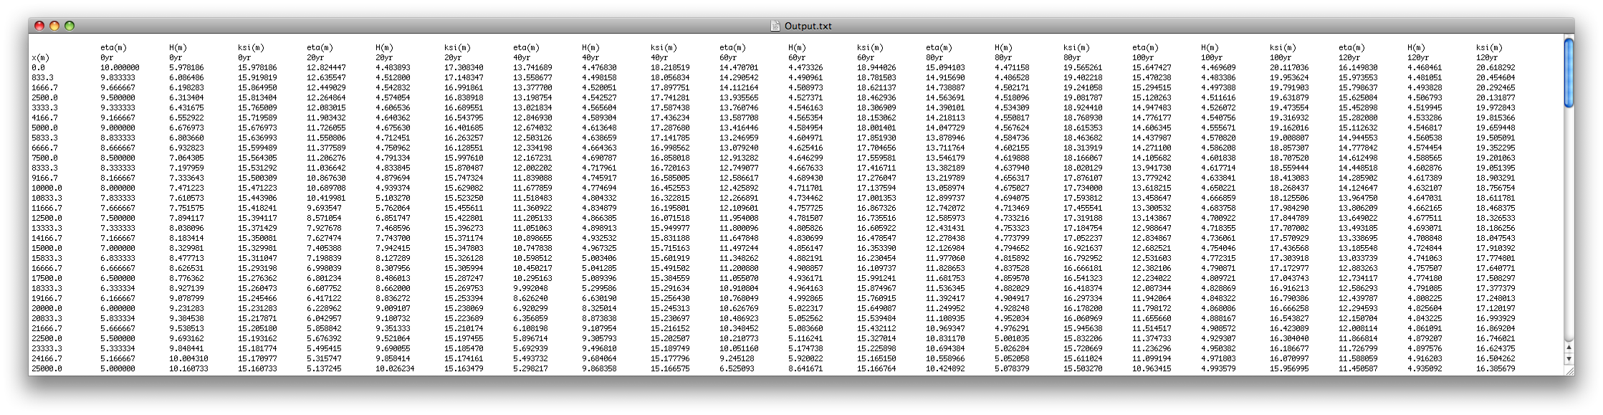

The additional parameters that the user may print at times t_{plot,j} in the text file Output1.txt are the channel slope, S, the Shields number, τ_{b}, and the total sediment transport rate, q_{t}. An example of the file Output1.txt is reported in the windows below. The parameters at t = 0 are representative of the condition of mobile-bed equilibrium antecedent to the change in annual sediment input rate or downstream water elevation.
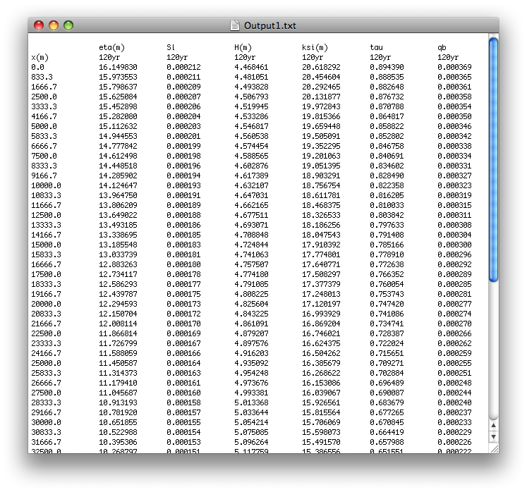

Notes:
- The downstream water surface elevation must exceed the H_{c}, critical depth, which is equal to (Q_{w}²/(B_{c}²g))^{1/3}, otherwise the user is alerted, and the program exits;
- In the original version of the code embedded in the excel file RTe-bookAgDegBW.xls the Manning-Strickler formulation is implemented;
- The water depth is calculated using a Chézy formulation, when only the Chézy coefficient is specified in the input text file. The Manning-Strickler formulation is implemented, when only the roughness height, k_{c}, and the coefficient α_{r} in eq. (5.i) are given in the input text file. When all the three parameters are present, the program will ask the user which formulation they would like to use
- Program prompts user whether they would like to append certain parameters to their output file (i.e. Output.txt), or whether they would like to create a separate file for these parameters. Included in these parameters are values such as flow depth at flood, Einstein number at flood, initial normal Froude number, ultimate normal Froude number, etc.

List of variables

x streamwise coordinate in m
Δx spatial step length in m
t temporal coordinate in seconds
C_{f} non-dimensional friction coefficient

Input
Q_{w} flood discharge in m³/s
I_{f} flood intermittency
B_{c} channel width in m
D characteristic grain size in mm
λ_{p} bed porosity
k_{c} composite roughness height in mm
S_{I} ambient bed slope
ξ_{d} imposed downstream water elevation in m
G_{tf} imposed annual sediment transport rate in tons/annum
L length of reach in m
Δt time step in yr
N_{toprint} number of time steps to printout
N_{print} number of printouts
M number of spatial intervals
a_{u} upwinding coefficient (1=full upwind, 0.5=central difference)
α_{r} coefficient in Manning-Strickler
α_{s} coefficient in sediment transport relation
n_{t} exponent in sediment transport relation
reference Shields number in sediment transport relation
ϕ_{s} fraction of bed shear stress due to skin friction
R submerged specific gravity
Cz non-dimensional Chézy friction coefficient

OUTPUT
η bed surface elevation in m
S bed slope
H water depth in m
ξ water surface elevation in m
τ_{b} total boundary shear stress on bed surface N/m²
q_{t} total bed material load in m²/s

7) AgDegNormalSub

The program computes the approach to mobile-bed equilibrium in a river carrying uniform material and flowing into a subsiding basin. It is a descendant of AgDegNormal. Three relatively minor changes have been implemented as follows:
- The input parameters have been modified to include the following parameters: subsidence rate σ, ratio of depositional width to channel width r_{B}, ratio of wash load deposited per unit bed material load Λ and channel sinuosity Ω;
- The code has been modified so as to include subsidence in the calculation of mass balance;
- The output has been modified to show the time evolution of not only the profile of bed elevation η, but also the profiles of bed slope S and the ratio q_{t}/q_{tf}, where q_{tf} denotes the volume feed rate of bed material load per unit width.

The new input parameters, i.e. ratio of depositional to channel width, r_{B}, units of wash load deposited per unit bed material load, Λ, and channel sinuosity, ω, have been introduced to generalize the Exner equation for uniform sediment from a flume-like setting, eq. (6.i) below, to a river, eq. (6.ii).
(7.i)
(7.ii)
where λ_{p} denotes the bed porosity, η is the bed elevation, q_{t} is the total sediment transport rate per unit channel width, I_{f} is the flow intermittency, t is the temporal coordinate and x is the streamwise (i.e. downchannel) coordinate.

The ratio of depositional to channel width, r_{B}, has been introduced to model the fact that in an aggrading river sediment deposits not only in the channel itself, but also in a much wider belt (e.g. the floodplain or basin width, due to overbank deposition, channel migration and avulsion). Here channel width is denoted as B_{c} (which can be taken to be synonymous with bankfull width) and effective depositional width is denoted as B_{d}. Both of these are taken as constant here for simplicity. r_{B} is thus defined as
(7.iii)

The parameter Λ that represents the units of wash load deposited per unit of bed material is introduced to consider that in the 1D formulation implemented in this model it is assumed that deposition occurs not only in the channel but on a much wider area (e.g. the floodplain). Sediment deposited in the channel is mostly made of bed material but sediment deposited around the channel contains a significant amount of wash load. A precise mass balance for wash load is beyond the scope of this model. For simplicity it is assumed that for every unit of sand deposited in the system, Λ units of wash load are deposited. It is also assumed that the supply of wash load from upstream is always sufficient for deposition at such a rate. This is not likely to be strictly true, but should serve as a useful starting assumption.

The parameter Ω has been introduced to consider that channels may be sinuous. Here it is assumed that the channel has a sinuosity, Ω, but that the depositional surface across which it wanders is rectangular. In the present formulation the sinuosity is defined as the ratio of downchannel distance per unit of downvalley distance.

For a detailed description of the theory and of the model, the user should refer to Chapters 4 “Relations for the Conservation of Bed Sediment”, 25 “Long Profiles of Rivers, with an Application on the Effect of Base Level Rise on Long Profiles” and 26 “Rivers Flowing into Subsiding Basins: Upward Concavity of Long Profile and Downstream Fining” of the e-book.

Boundary and initial conditions are equal to that implemented for the ancestor model AgDegNormal.

The input parameters of the model are specified in a slightly different form than those of AgDegNormal. The input parameters of AgDegNormalSub are listed below:
- the characteristic flood discharge per unit channel width, q_{w}, and the flood intermittency, I_{f};
- the characteristic diameter of the sediment, D;
- the bed porosity, λ_{p};
- the roughness height, k_{c};
- the ambient bed slope, S;
- the volume sediment feed rate per unit channel width, q_{tf};
- the subsidence rate, σ;
- the ratio of depositional width to channel width, r_{B};
- the channel sinuosity, Ω;
- the units of wash load deposited in the system per unit of bed material load, Λ;
- the length of the fluvial reach, L;

The user also has to specify the following parameters to perform the calculations and to control the output:
- the number of sub-reaches, M;
- the temporal step length, Δt;
- the upwinding coefficient a_{u};
- the number of time steps to printout, N_{toprint};
- the numbers of printout in addition to the initial equilibrium state, N_{print};
- the coefficient α_{r} in eq. (5.i);
- the parameters to define the load relation, 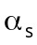,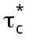 and n_{t}, defined in eq. (5.ii);
- the constant to convert the total boundary shear stress to that due to skin friction, ϕ_{s};
- the submerged specific gravity of the sediment, R.

The text file with the definition of the input parameters and an example of input file are shown in the two windows below.
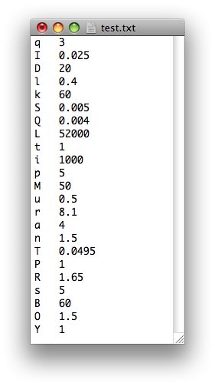
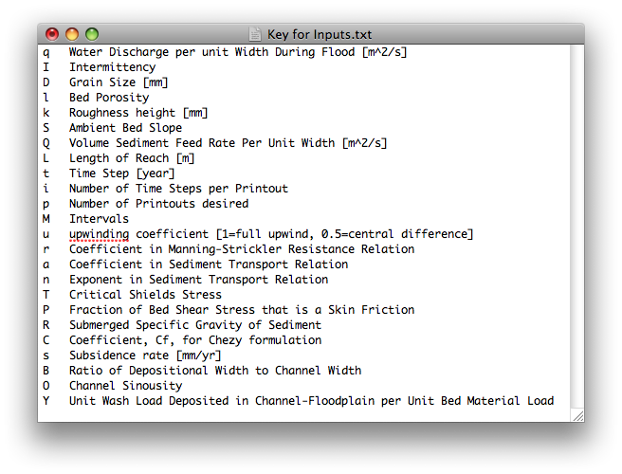

The output parameters of the model printed in the text file Output.txt are the bed elevation, η, the channel slope, S, and the ratio between the transport and the feed rate of bed material load.
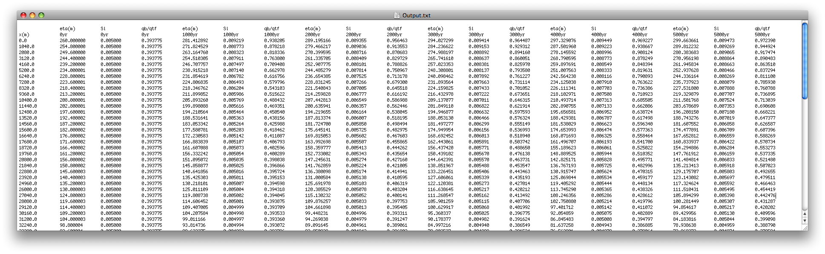

The additional parameters that the user may print at times t_{plot,j} in the text file Output1.txt are the channel slope, S, the water depth, H, the Shields number, τ_{b}, and the total sediment transport rate, q_{t}. An example of the file Output1.txt is reported in the windows below.

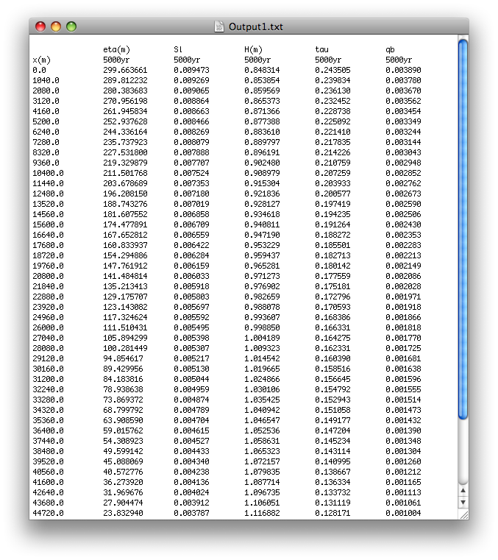
Notes:
- Flow is calculated assuming normal flow approximation;
- In the original version of the code embedded in the excel file RTe-bookAgDegNormSub.xls the Manning-Strickler formulation is implamented;
- The water depth is calculated using a Chézy formulation, when only the Chézy coefficient is specified in the input text file. The Manning-Strickler formulation is implemented, when only the roughness height, k_{c}, and the coefficient α_{r} in eq. (5.i) are given in the input text file. When all the three parameters are present, the program will ask the user which formulation they would like to use
- If the input channel length is longer than the maximum possible length of the fluvial reach, the program cannot perform the calculation. The maximum possible length of the fluvial reach, L_{max}, is defined as the maximum length of basin that the sediment supply can fill; at this length the sediment transport rate out of the basin drops precisely to zero (see Chapter 26 “Rivers Flowing into Subsiding Basins: Upward Concavity of Long Profile and Downstream Fining” of the e-book). For the Exner equation generalized for a river, eq. (7.ii), L_{max} is computed as
(7.iv)

List of variables

x downchannel coordinate in m
Δx spatial step length in m
t temporal coordinate in seconds
B_{c} channel width in m
B_{d} width of the depositional area in m
L_{max} maximum possible length of the modeled reach in m

Input
q_{w} flood discharge per unit channel width m²/s
I_{f} flood intermittency
D grain size in mm
λ_{p} bed porosity
k_{c} composite roughness height in mm
SI initial bed slope
qtf sediment input rate of bed material load per unit channel width in m²/s
σ subsidence rate in mm/yr
r_{B} ratio between the depositional and the channel width
Ω channel sinuosity
Λ units of wash load deposited per unit of deposited bed material load
L length of reach in m
Δt time step in yr
N_{toprint} number of time steps to printout
N_{print} number of printouts
M number of spatial intervals
a_{u} upwinding coefficient (1=full upwind, 0.5=central difference)
α_{r} coefficient in Manning-Strickler
α_{s} coefficient in sediment transport relation
n_{t} exponent in sediment transport relation
reference Shields number in sediment transport relation
ϕ_{s} fraction of bed shear stress due to skin friction
R submerged specific gravity
Cz non-dimensional Chézy friction coefficient

OUTPUT
η bed surface elevation in m
S bed slope
H water depth in m
τ_{b} total boundary shear stress on bed surface N/m²
q_{t} total bed material load in m²/s
q_{t}/q_{tf} ratio between the sediment transport and feed rate of bed material
8) AgDegNormalFault

The program AgDegNormalFault is an extension of AgDegNormal for sudden vertical faulting of the bed, as shown in the figure below.

η
d
f, fraction of L
Bed Surface

The bed downstream of the point x = r_{f}L (0 < r_{f} < 1), where x is a streamwise coordinate and L is the length of the modeled reach, is suddenly faulted downward by an amount Δη_{f} at time t_{f}. The eventual smearing out of the long profile is then computed.

The initial condition for the model is the bed at mobile equilibrium for the specified boundary conditions, i.e. characteristic flood discharge, Q_{w}, flood intermittency, I_{f}, and bed slope.

Input parameters of the model are
- the characteristic flood discharge, Q_{w}, and the flood intermittency, I_{f};
- the channel width, B_{c};
- the characteristic diameter of the sediment, D;
- the bed porosity, λ_{p};
- the roughness height, k_{c};
- the ambient bed slope, S;
- the imposed annual sediment transport rate, G_{tf};
- the fraction of reach length such that all points downstream of x = r_{f}L undergo downward faulting, r_{f};
- the height of faulting, Δη;
- the time from beginning of calculation at which faulting occurs, t_{f};
- the length of the fluvial reach, L;

The user also has to specify the following parameters to perform the calculations and to control the output:
- the number of sub-reaches, M;
- the temporal step length, Δt;
- the upwinding coefficient a_{u};
- the number of time steps to printout, N_{toprint};
- the numbers of printout in addition to the initial equilibrium state, N_{print};
- the coefficient α_{r} in eq. (5.i);
- the parameters to define the load relation, , and n_{t}, defined in eq. (5.ii);
- the constant to convert the total boundary shear stress to that due to skin friction, ϕ_{s};
- the submerged specific gravity of the sediment, R.

The text file with the definition of the input parameters and an example of input file are shown in the two windows below.

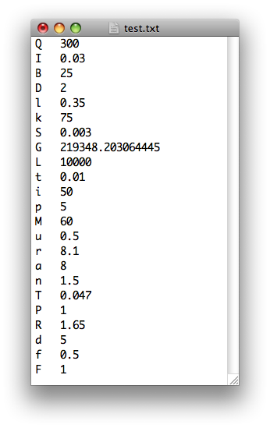
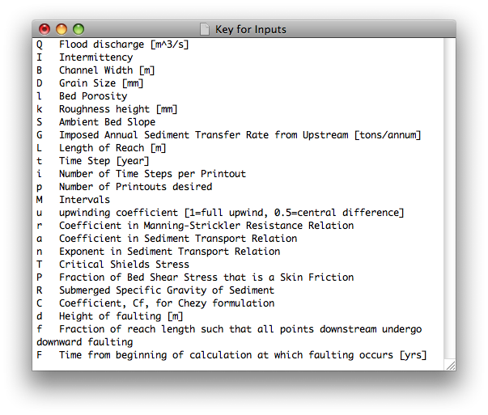

The outputs of the model are N_{print} longitudinal profiles at different times t_{plot,j} defined by eq. (5.viii).
An example of the output file Output.txt is reported in the window below with an example of the additional parameters that the user may want to plot in the text file Output1.txt, i.e. bed slope, S, water depth, H, Shields number, τ_{b}, and the total bed material load, q_{t}. The initial bed profile is the bed profile at mobile-bed equilibrium, given the water discharge, the flow intermittency and the initial bed slope.

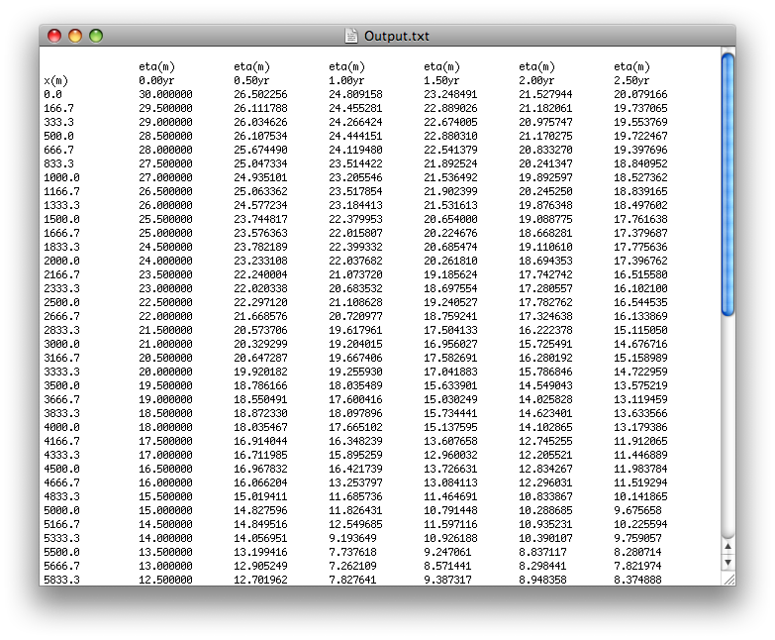

Notes:
- If the channel slope is negative and the water depth is not a number, “nan”, check the time step and the spatial step length. In particular, the time step may be too large or equivalently the spatial step length may be too small. Change these values and run the model again;
- The water depth is calculated using a Chézy formulation, when only the Chézy coefficient is specified in the input text file. The Manning-Strickler formulation is implemented, when only the roughness height, k_{c}, and the coefficient α_{r} in eq. (5.i) are given in the input text file. When all the three parameters are present, the program will ask the user which formulation they would like to use.

List of variables

x streamwise coordinate in m
Δx spatial step length in m
t temporal coordinate in seconds
C_{f} non-dimensional friction coefficient

Input
Q_{w} flood discharge in m³/s
I_{f} flood intermittency
B_{c} channel width in m
D characteristic grain size in mm
λ_{p} bed porosity
k_{c} composite roughness height in mm
S_{I} ambient bed slope
G_{tf} imposed annual sediment transport rate in tons/annum
r_{f} faction of reach length such that all points downstream of x = r_{f}L undergo downward faulting.
Δη height of faulting in m
t_{f} time from beginning of calculation at which faulting occurs in years
L length of reach in m
Δt time step in years
N_{toprint} number of time steps to printout
N_{print} number of printouts
M number of spatial intervals
a_{u} upwinding coefficient (1=full upwind, 0.5=central difference)
α_{r} coefficient in Manning-Strickler
α_{s} coefficient in sediment transport relation
n_{t} exponent in sediment transport relation
reference Shields number in sediment transport relation
ϕ_{s} fraction of bed shear stress due to skin friction
R submerged specific gravity
Cz non-dimensional Chézy friction coefficient

OUTPUT
η bed surface elevation in m
S bed slope
H water depth in m
τ_{b} total boundary shear stress on bed surface N/m²
q_{t} total bed material load in m²/s

9) AgDegNormGravMixPW

The program AgDegNormGravMixPW is an extension of AgDegNormal for sediment mixtures in gravel bed rivers where the channel bed material is transported as bedload only. Gravel-bed rivers tend to be poorly-sorted. During floods, bed material load consists almost exclusively of bedload. (Sand is often transported in copious quantities as washload during floods.) The surface material (armor or pavement) tends to be coarser than the substrate. By definition the median size D_{sub50} or geometric mean size D_{subg} of the substrate is in the gravel range, but the substrate may contain up to 30% sand in the interstices of an otherwise clast-supported deposit. The Exner equation of conservation of channel bed sediment, eq. (5.iii), is thus written as
(9.i)
where λ_{p} is the bed porosity, η is the bed elevation above a datum, t is a temporal coordinate, I_{f} is the flow intermittency, x is a streamwise coordinate and q_{bT} denotes the total volumetric bedload transport rate per unit channel width.

The grain size distribution of the bed material is specified in terms of 12 size bounds, D_{bi} with i = 1 …12, such that f_{fi} denotes the mass fraction of the sample that is finer than D_{bi}. The 12 bound diameters specify 11 grain size ranges defined by (D_{b,i}, D_{b,i+1}) and (f_{f,i}, f_{f,i+1}). For each size range the model computes the characteristic diameter, D_{i}, and the fraction of sample in the ith size range, f_{i}, with the equations (9.ii a, b) reported below.
(9.ii a, b)

The flow is assumed normal and the water depth can be computed with either a Manning-Strickler (implemented in the worksheet Rte-bookAgDegNormGravMixPW.xls) or a Chezy formulation can be used.

The exchange of sediment between the bedload and the bed deposit is modeled with a two-layer model for the channel bed. The bed deposit is divided in two regions, 1) the substrate and 2) the active (or surface or armor) layer, as represented in the figure below, where η denotes the channel bed elevation above a datum, L_{a} is the thickness of the active layer and H is the water depth.
datum
substrate
active layer
water
bed deposit
η
η - L_{a}
L_{a}
H

The grain size distribution of the active layer is assumed to be constant in the vertical and it may vary in the streamwise direction and in time, i.e. the active layer is assumed well-mixed. The grain size distribution of the substrate, in principle, may vary in both streamwise and vertical direction, but it is constant in time. The only way the grain size distribution of the substrate may vary in time is by creating new substrate via bed aggradation. In the present model, the grain size distribution of the substrate is assumed to be constant in space and in time, therefore it works only for the cases of aggradation always and everywhere or degradation always and everywhere. In the case of aggradation followed by degradation, it is necessary to modify the code so that the vertical variation of the grain size distribution of the new substrate created by aggradation is stored in memory.

The evolution in time and space of the grain size distribution of the active layer is described by the grain-size based Exner equation, eq. (9.iii), that expresses the conservation of sediment in each grain size range.
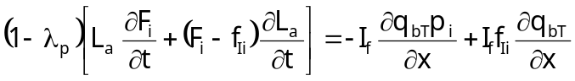 (9.iii)
F_{i}, p_{i} and f_{Ii} respectively represent the fraction of sediment in the ith grain size range in the active layer, in the bedload and at the active-layer substrate interface. The grain size distribution of the sediment at the active layer substrate interface is defined in eq. (9.iv). It is equal to the weighted average between the grain size distribution of the active layer and of the bedload when the bed aggrades and the grain size distribution of the substrate when the bed degrades.
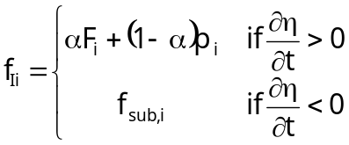 (9.iv)
where α is a user specified parameter and f_{sub,i} denotes the fraction of substrate material in the ith size range.

No attempt is made in this code to decompose the bed resistance into skin friction and form drag. The constant to convert total boundary shear stress to that due to skin friction, ϕ_{s}, is set equal to 1 and consequently the composite roughness height for the Manning-Strickler formulation, k_{c}, is equal to the roughness height due to skin friction, k_{s}, eq. (4.iv). The roughness height and the thickness of the active layer are computed with the liner functions of the diameter of the bed surface such that the 90% of the sediment is finer, D_{s90}, reported in eq. (9.v a, b)
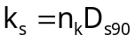 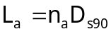 (9.v a, b)
where n_{k} and n_{a} are user specified order-one non dimensional constants.

To compute the bedload transport rate the user can choose from two surface-based bedload transport formulations; those of Parker (1990) and Wilcock and Crowe (2003). In the relation of Parker (1990) the surface grain size distributions need to be renormalized to exclude sand before specification as input to the program. This step is neither necessary nor desirable in the case of the relation of Wilcock and Crowe (2003), where the sand plays an important role in mediating the gravel bedload transport.

For a detailed description of the theory and of the model the user may refer to Chapters 4 “Relations for the Conservation of Bed Sediment”, 7 “Relations for 1D Bedload Transport”, 17 “Aggradation and Degradation of Rivers Transporting Gravel Mixtures” and 18 “Mobile and Static Armor in Gravel-bed Streams” of the e-book.

The upstream boundary conditions are given in terms of specified values of water discharge per unit width, q_{w}, and volumetric total gravel input rate per unit width, q_{bTf}, with its grain size distribution, given in terms of bound diameters, D_{bi}, and percent finer, p_{ffi}. The downstream boundary condition is a fixed bed elevation η_{d} at the downstream end of the modeled reach, i.e. the Exner equation (9.i) is not implemented at node M+1.

The initial conditions are a specified initial bed profile here simplified to a specified initial bed slope S_{l} (S_{fbI} in the excel file RTe-bookAgDegNormGravMixPW.xls), see eq. (5.vii). The grain size distributions of the active layer, F_{fi}, and of the substrate, f_{subfi}, have to be specified and they are assumed to be the same in each computational node. These grain size distributions are expressed in terms of bound diameters, D_{bi}, and percent finer, respectively F_{fIi} for the bed surface and F_{subfi} (F_{fsi} in the excel file RTe-bookAgDegNormGravMixPW.xls).

Input parameters of the model are
- the characteristic flood discharge per unit channel width, q_{w}, and the flood intermittency, I_{f};
- the volumetric gravel input rate per unit channel width, q_{bTf};
- the downstream bed elevation, η_{d};
- the bed porosity, λ_{p};
- the initial bed slope, S_{I};
- the length of the fluvial reach, L;
- the grain size distributions of the substrate of the active layer and of the gravel feed rate. The bound diameters, D_{bi}, are the same for the three distributions;

The user also has to specify the following parameters to perform the calculations and to control the output:
- the number of sub-reaches, M;
- the temporal step length, Δt;
- the upwinding coefficient a_{u};
- the number of time steps to printout, N_{toprint};
- the numbers of printout in addition to the initial equilibrium state, N_{print};
- the coefficient α_{r} in eq. (4.iv);
- the coefficient n_{k} in eq. (9.v a) to compute the roughness height;
- the coefficient n_{a} in eq. (9.v b) to compute the thickness of the active layer;
- the load relation, i.e. Parker (1990) or Wilcock and Crowe (2003);
- the submerged specific gravity of the sediment, R;
- the parameter α in eq. (9.iv) that governs the grain size distribution of the sediment at the active layer-substrate interface during bed aggradation.

The text file with the definition of the input parameters and an example of input file are shown in the two windows below.

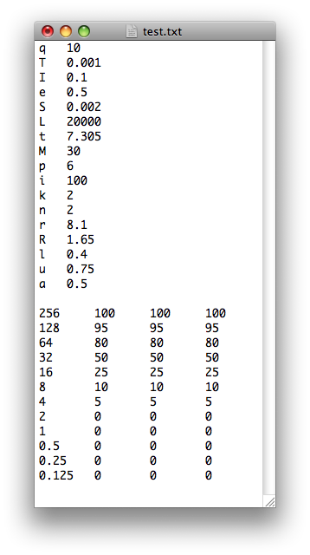
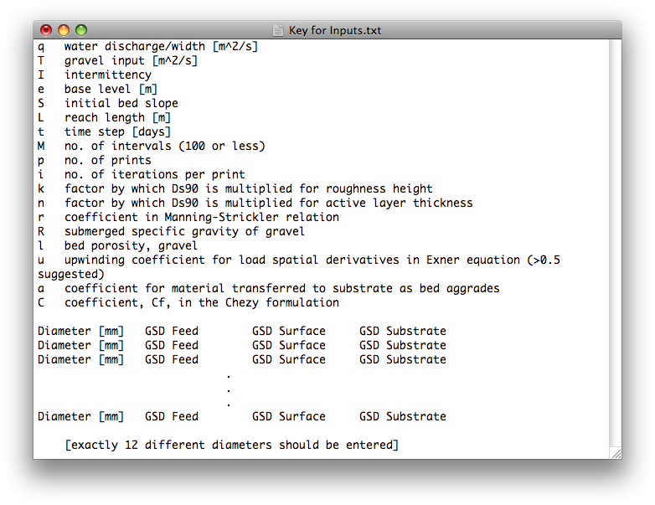

The output parameters of the model printed in the text file Output.txt are the bed elevation, η, the geometric mean diameter of the bed surface, D_{sg}, and the ratio between the bedload transport rate and the feed rate.

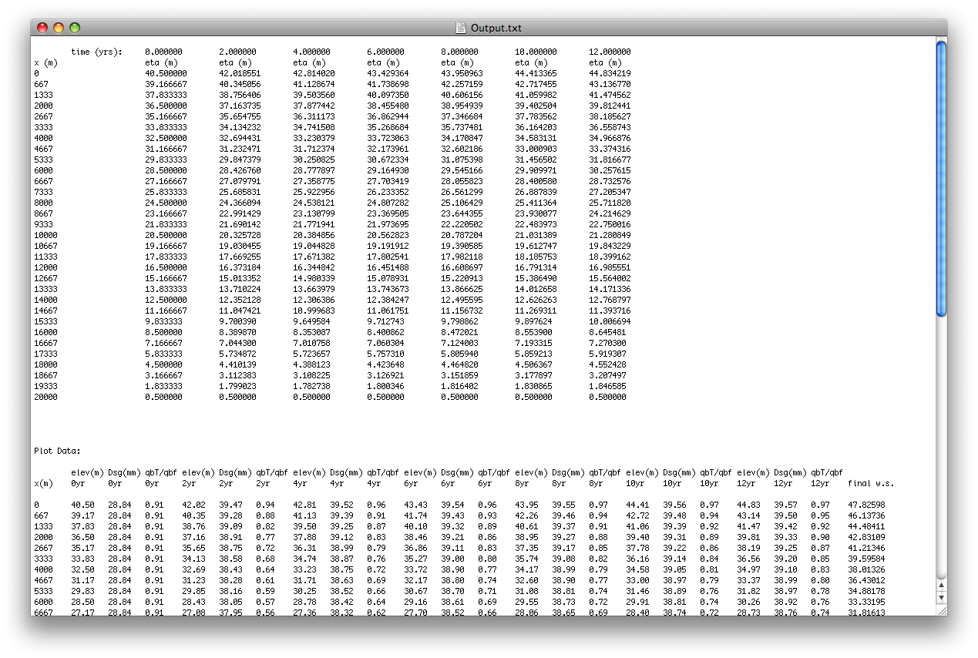

The additional parameters that the user may print at times t_{plot,j} in the text file Output1.txt are the channel slope, S, the water depth, H, the total bedload transport rate, q_{bT}, the diameter of the bed surface such that 90% of the sediment is finer, D_{s90}, the Shields number, , i.e. the non-dimensional Shields number, defined as
(9.vi)
where τ_{b} is the bed shear stress, ρ_{s} and ρ respectively denote the density of the sediment and of the water, g is the acceleration of gravity and D_{sg} is the geometric mean diameter of the bed surface.
An example of the file Output1.txt is reported in the windows below.

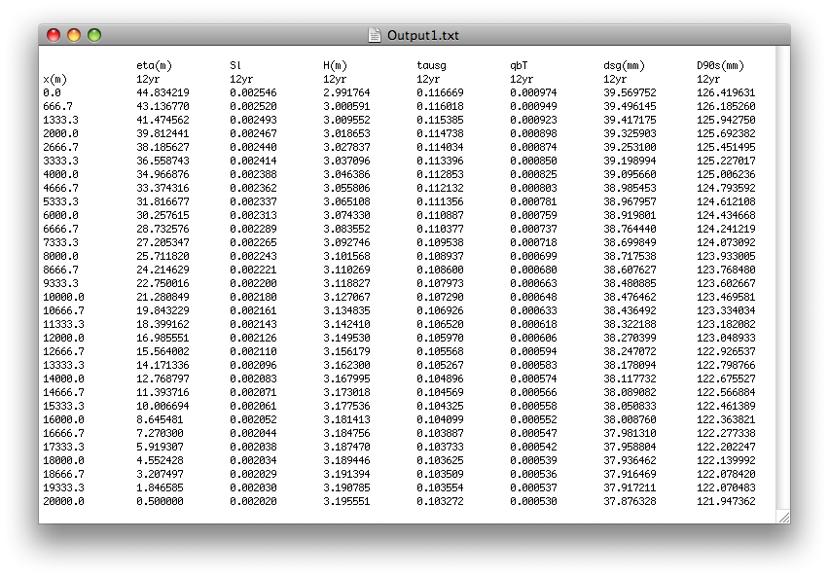

Notes:
- In the case of the load relation due to Parker (1990), the grain size distributions are automatically renormalized because the relation is for the transport of gravel only
- In the case of the load relation due to Wilcock-Crowe (2003), the sand and the fine sediment are retained for the computation;
- The user will be prompted by the program as to which bedload relation he would like to use;
- The input grain size distributions may be on a 0-100% or a 0.00-1.00 scale, and the program will automatically scale;
- The input grain size distributions must have bounds at 0% and 100% (1.00) to properly perform the calculation. If the user does not input the bounds the program will automatically interpolate upper and lower bounds D_{bU} and D_{bL} such that f_{fU} = 100 (1.00) and f_{fL} = 0;
- The water depth is calculated using a Chézy formulation, when only the Chézy coefficient is specified in the input text file. The Manning-Strickler formulation is implemented, when only the coefficients α_{r} and n_{k} in equations (4.iv) and (4.v) are given in the input text file. When all the three parameters are present, the program will ask the user which formulation they would like to use.

List of variables

x downchannel coordinate in m
Δx spatial step length in m
t temporal coordinate in seconds
k_{s} roughness height due to skin friction only in mm
C_{f} Manning-Strickler friction coefficient
L_{a} thickness of the active layer in m
f_{fi} fraction of sediment finer than the ith bound diameter
f_{i} fraction of sediment in the ith grain size range

Input
q_{w} flood discharge per unit channel width m²/s
I_{f} flood intermittency
λ_{p} bed porosity
S_{I} initial bed slope
η_{d} bed elevation at the downstream end of the reach in m
q_{bTf} total bedload input rate per unit channel width in m²/s
L length of reach in m
Δt time step in days
N_{toprint} number of time steps to printout
N_{print} number of printouts
M number of spatial intervals
a_{u} upwinding coefficient (1=full upwind, 0.5=central difference)
α_{r} coefficient in Manning-Strickler formulation
α parameter in eq. (9.iv) that governs the grain size distribution of the sediment at the active layer-substrate interface during bed aggradation
n_{k} coefficient to estimate the roughness height as a function of the D_{s90}
n_{a} coefficient to estimate the thickness of the active layer as a function of the D_{s90}
R submerged specific gravity of the sediment
Cz non-dimensional Chézy friction coefficient
D_{bi} bound diameters of the grain size distribution
D_{i} characteristic diameters of the grain size distribution defined in eq. (9.ii a)
F_{i}, f_{subi}, p_{i}, f_{Ii}, fractions of sediment in the ith grain size range of the bed surface, of the substrate, of the bedload and at the active layer-substrate interface
OUTPUT
η bed surface elevation in m
S bed slope
H water depth in m
τ_{sg} Shields number computed with eq. (9.vi)
q_{bT} total bedload transport rate per unit channel width in m²/s
q_{bT}/q_{bTf} ratio between the total bedload transport and the feed rate per unit channel width
D_{sg} geometric mean diameter of the bed surface in mm
D_{s90} diameter of the active layer such that the 90% of the sediment is finer in mm

References:

Parker, G., 1990, Surface-based bedload transport relation for gravel rivers, Journal of Hydraulic Research, 28(4): 417-436.
Wilcock, P. R., and Crowe, J. C., 2003, Surface-based transport model for mixed-size sediment, Journal of Hydraulic Engineering, 129(2), 120-128.

10) AgDegNormGravMixHyd

This program is a close relative of AgDegNormGravMixP. It computes aggradation and degradation in gravel-bed river subject to a repeated hydrograph. The sediment is modeled as mixture of different grain sizes and the bedload formulation is that of Parker (1990) that was derived to compute the transport of gravel only. For a more extensive description of the theory and of the model the user can refer to Chapter 19 “Effect of Hydrograph on Morphology of Gravel-bed Streams” of the e-book.

To perform a numerical calculation with a flow hydrograph, the actual hydrograph must be specified in terms of W constant water discharges Q_{w}, where w = 1 … W, each extending for time duration Δt_{w}. The river is assumed to be morphologically inactive when it is not in flood.
The morphodynamic evolution is computed solving the equation of sediment continuity (i.e. Exner equation). A short flood time step, Δt_{f}, is used to solve the Exner equation. It is convenient to choose each time duration Δt_{w} to be an integer number, n_{step,w}, of the flood time step, so that
(10.i)
Once Δt_{f} is specified along with Q_{w} and n_{step,w} for all the W constant water discharges, it is possible to determine a discharge Q_{p} for each time step p = 1 … P in the hydrograph, where
(10.ii)

The flow is assumed locally normal and it is computed with a Manning-Strickler formulation, eq. (4.iv). No attempt is made to decompose the bed resistance into skin friction and form drag. The roughness height and the active layer thickness are assumed functions of the grain size distribution of the bed surface and they are computed with eqs. (9.v a, b).

Initial conditions are the initial bed profile and the grain size distribution of the bed surface and of the substrate. The initial bed profile, as in AgDegNormGravMixPW, is specified in terms of a constant slope, S_{I} (S_{fbI} in the excel worksheet RTe-bookAgDegGravMixHyd.xls), and a downstream bed elevation, η_{d}. The grain size distributions of the bed surface and of the substrate are specified in terms of percent finer and n_{pp} bound diameters, D_{bi}, with n_{pp} = 2 ~ 9. All the grain size distributions must be specified with the same n_{pp} bound diameters and the fractions of sediment finer than the bound diameters can be given either on a 0 – 100 or 0 – 1 scale. If the fraction of sediment finer than the lower (upper) bound of the input distributions is grater than zero (100 or 1), the program automatically computes a new lower (upper), D_{bnew}, bound of the distribution such that the fraction of sediment finer than D_{bnew} is equal to 0 (100 or 1). The fraction of sand (D_{b,i} < 2 mm) in the input the grain size distributions has to be removed and the distributions need to be renormalized before starting the calculations.

The upstream boundary condition is given in terms of W values of water discharge, bedload input rate and n_{step,w}.

